Shabbos Stories for
Rosh Hashanah 5784
Volume 15, Issue 1 – 1-2 Tishrei 5784/September 16-17, 2023
Printed L’illuy nishmas Nechama bas R’ Noach, a”h
For a free subscription, please forward your request to keren18@juno.com
Past emails can be found on the website – ShabbosStories.com
Elijah the Prophet in Minsk
By Yitzchak Buxbaum

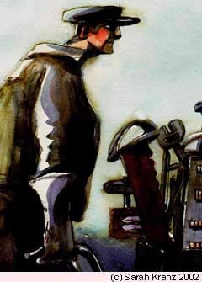

A Chassid went to the Baal Shem Tov in Mezhibuzh and said, “Rebbe, I want to see Elijah the Prophet.”
“It’s simple,” said the Baal Shem. “I’ll tell you what to do. Get two boxes and fill one with food and the other with children’s clothes. Then, before Rosh Hashanah, travel to Minsk. On the outskirts of town, right before where the forest begins, is a dilapidated house. Find that house, but don’t knock on the door immediately; stand there for a while and listen. Then, shortly before candle-lighting time at sunset, knock on the door and ask for hospitality.”
The Chassid went home and told his wife he would be away for the holiday. “How can you leave your family?” she said. “The children want their father to take them to the synagogue!”
He told her, “I have a once-in-a-lifetime chance to see Elijah the Prophet!” Finally, she agreed that it was something that he could not pass up.
So, he went and did as the Baal Shem Tov told him. He filled the parcels with food and clothing and went to Minsk, where he found the broken-down house at the edge of town. He arrived shortly before evening and stood in front of the door, listening. Inside, he heard children crying, “Mommy, we’re hungry. And it’s Yom Tov and we don’t even have decent clothes to wear!” He heard the mother answer, “Children, trust in G-d. He’ll send Elijah the Prophet to bring you everything you need!”
Then the Chassid knocked on the door. When the woman opened it, he asked if he could stay with them for the holiday.

“…I Don’t Have Any Food in the House”
“How can I welcome you when I don’t have any food in the house?” she said. “Don’t worry,” he said, “I have enough food for all of us.” He came in, opened the box, gave the children the food, and they ate. Then he opened the other box and the children all took clothes for themselves: this one a shirt, that one a jacket, the other one a hat. He was there for two days, waiting to see Elijah the Prophet. He did not even sleep. How could he sleep? How often do you get a chance to see Elijah the Prophet? But he saw no one.
So, he returned to the Baal Shem Tov and said, “Master, I did not see Elijah the Prophet!”

The Baal Shem Tov Questions His Chasid
“Did you do everything I told you?” asked the Baal Shem Tov.
“I did!” he said.
“And you didn’t see him?”
“No, Rebbe.”
“Are you sure?”
“Yes, Rebbe! I didn’t see him!”
“Then you’ll have to return for Yom Kippur,” said the Baal Shem Tov. “Go back before Yom Kippur, with a box of food, to the same house. Again, be sure to arrive an hour before sunset, and don’t knock immediately. Wait for a while and just stand in front of the door, listening.”
The Chassid went back to his wife and told her he would be away for Yom Kippur. “How can you leave your children again?” she asked. “But the Baal Shem Tov says I’ll be able to see Elijah the Prophet, like one of the great tzaddikim!” he said, “How can I not go?”
His wife agreed that it was worth going away for two or three days if he could see Elijah the Prophet.
So, he went back to Minsk before Yom Kippur. This time, he went earlier and stood in front of the door, listening. Inside he heard children crying, “Mommy, we’re hungry! We haven’t eaten the whole day! How can we fast for Yom Kippur?”
“Children!” said the mother. “Do you remember you were crying before Rosh Hashanah that you had no food or clothes? And I told you, ‘Trust in G-d! He’ll send Elijah the Prophet, who’ll bring you food and clothing and everything else you need!’ Wasn’t I right? Didn’t Elijah come and bring you food and clothing? He stayed with us for two days! Now you’re crying again that you’re hungry. I promise you that Elijah will come now, too, and bring you food!”
Then the Chassid understood what his master, the Baal Shem Tov, had meant. And he knocked on the door.

Reprinted from the Parshat Ki Seitzei 5783 website of Chabad.Org Magazine.

Story #1293
The Sound of Silence
From the Desk of Yerachmiel Tilles
editor@ascentofsafed.com

The Jews from a small town near the city of Ushomir, in the Ukraine, suffered greatly from the antagonism of the estate manager where many of them worked. Nothing they did could meet with the man’s approval, and it seemed as if he pursued them day and night in order to find fault with them. He even reduced their salary at every opportunity, each time citing a different picayune reason.

A Jew by Accident of Birth Only
This seemingly anti-Semitic manager was actually a Jew himself. None of the Jews in the region knew where he had come from, or anything about his past. The present, however, was clear: he was a Jew by accident of birth only, and even that seemed to be a bit too much for him to bear.
A week before Rosh Hashana, a visiting Tzadik arrived in Ushomir, Rabbi Mordechai-Dov of Hornisteipl. It was his habit to travel around to the cities and towns in his area during the month before Rosh Hashana in order to arouse the people to repent and turn closer to G-d in preparation for the awesome Day of Judgment. He planned to spend Shabbat in Ushomir, and to speak in its main synagogue.
As the word spread that the famed Chassidic master would be in the city, Jews from all the neighboring towns and villages flocked to Ushomir. The Shabbat was as spiritually exhilarating as everyone had hoped for, and after the closing Havdalah ceremony, all the guests lined up to take leave of the rebbe and to receive his farewell blessing.

The Oppressive Manager was Himself a Jew
The Jews from the small town that suffered from the estate manager agreed among themselves that they would each mention the situation to the rebbe. Rabbi Mordechai listened with full attention to each one, and they could feel that he shared in their woe. They also saw that his sorrow was even greater from the awareness that the oppressive manager was himself a Jew.
He gave each one the same answer: “Be patient until tomorrow, and we will see what can be done.”
The next day, after the morning prayers, Rabbi Mordechai told his attendants to immediately prepare to depart. But to everyone’s surprise, he instructed them not to travel in the direction they had originally planned, but instead to head for the nearby village. The villagers who hadn’t yet returned home were also taken by surprise, and they hurried to pack their wagons in order to travel together with the rebbe.
Soon a long caravan snaked along the dusty road, with the carriage of the Hornisteipler Rebbe leading the way. As soon as they arrived, the rebbe asked for directions to the residence of the estate manager.

The Locals Wondered what the Holy Man Would Do
As they approached the impressive house of the estate manager, all those accompanying the rebbe, as well as many from the village who had joined the procession, waited breathlessly to see what he would do. The locals wondered if perhaps the holy man would cast his gaze on the source of their misery and turn him into a heap of smoldering bones!
Meanwhile, the estate manager stood, unmoving, on the expansive balcony of his home. The pipe in his mouth and his general appearance testified to his haughty attitude, but as they drew closer they could see from the expression on his face that he was a bit puzzled. What was the meaning of this extensive delegation rolling towards his property?
The Hornisteipler Rebbe instructed his coachman to drive right up to the entrance of the house. This he did, as all the other carriages lined up behind his in a long row stretching back onto the road. Only then did the rebbe raise his eyes and, after a glance at the fancy house, stare straight at the estate manager on the terrace. The manager looked back at him. The rebbe’s gaze didn't waver, and for an endless few-minutes the two stared at each other.
Suddenly Rabbi Mordechai climbed down from his carriage and walked firmly towards the door. The estate manager quickly disappeared within the house, and a few moments later the door swung open from within. All the bystanders watched excitedly from their places to see what would happen next.

The Rebbe Enters the House
The rebbe and one of his attendants entered the house. After a few minutes they emerged and went back into their carriage. The driver tugged the reins, the horses reversed their direction, and they drove away.
Only at a later time were the townspeople able to find out, from the rebbe’s attendant, what had transpired inside the house. They learned that from the moment the estate manager opened the door to his house until the moment the rebbe and his attendant stepped out, not a word had been uttered!
With a slight nod of his head, the manager signaled them to enter. Then, with a flourish of his hand he motioned the rebbe to sit in a chair he had placed for him, while he himself sat in a chair opposite him.
The rebbe placed his hands on the table between them, straightened his back and stared fixedly into the eyes of the estate manager. The latter looked back cynically.

The Manager’s Defiant Stare Began to Soften
Thus, they sat long moments, unmoving. The stare of the manager, which had been defiant, began to soften. At the same time, the rebbe’s gentle gaze intensified and his pure, holy eyes seemed to harden.
Then, to his surprise, the rebbe’s attendant noticed that the manager’s eyes were moist. A large tear formed and rolled slowly down his cheek. At that moment, the rebbe rose from his seat and walked to the door, still not having said a word. The manager remained frozen in his chair, as if paralyzed; he couldn’t even manage to escort his guests out.
The rebbe remained the rest of the day in the village. All those who missed the opportunity in Ushomir went to him to receive his blessing. Towards evening the lines thinned, and eventually the home at which the rebbe was staying became empty of guests.
But a silent, shadowy figure was seen approaching the house. His soft knock broke the dusky silence. It was the estate manager. His frightened eyes and the manner in which he slipped inside made it seem as if someone were chasing him. He and the rebbe went into an isolated room, and remained there for two hours.
That Rosh Hashanah, an unexpected visitor arrived at the shul to join the prayers of the Day of Judgment. This, of course, was the estate manager, who for the entire two days of the holiday practically didn’t move from his spot.
With a tallit covering his head and upper part of his face, he stood nearly the entire time, praying with copious tears. The man who had been so alienated and removed from Judaism was from that day on a full penitent, and also acted with kindness towards his Jewish brethren.
~~~~~~~~~~~~~~~
Source: Translated by Yerachmiel Tilles from the popular Hebrew weekly, Sichat HaShavua. First published on //Chabad.org.
Connection: The story begins in the week of Selichot and ends on Rosh Hashana!
Biographical note: Chassidic master Rabbi Mordechai Dov Twerski of Hornisteipl (1840â€“1904) was named after his two maternal great-grandfathers, Rabbi Mordechai of Chernobyl and Rabbi Dov Ber of Lubavitch. In addition, he was a direct descendant of Rabbi Zusha of Anipoli, and the son-in-law of Rabbi Chaim of Sanz. A highly respected Talmudic scholar, he was also the author of a popular book of Chassidic guidance, Pele Yoetz.

Reprinted from the Rosh Hashanah 5783 email of KabbalaOnline.org, a project of Ascent of Safad.
Who by Fire
By Elissa (Galster) Davidson
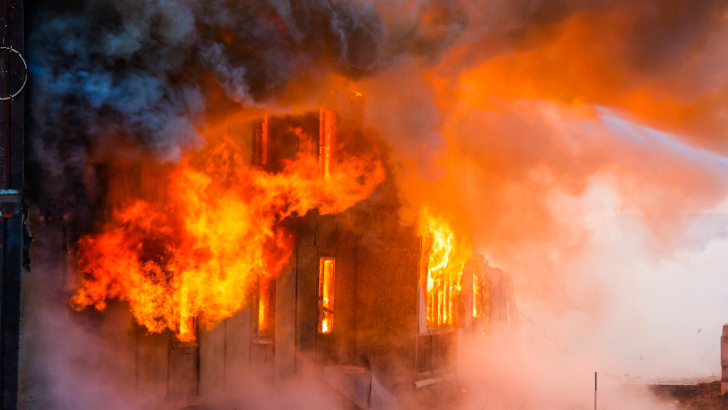

It was 4 PM on the hottest day of the year in New Jersey. I had just fallen asleep on the couch after an enjoyable Shabbos meal with friends, exhausted from the 15-minute walk home in the heat.
I was in the middle of a vivid dream when suddenly a noise jolted me awake. I heard a loud alarm crying out. My thoughts raced but I didn't panic. This must be a false alarm.
I got increasingly nervous as I walked through the dining room, down the hallway and turned the corner. The ringing got louder and more intense as I made my way closer to my bedroom door. My roommates were away for Shabbos; I was all alone.

That’s When Panic Set In
I turned the door handle and saw a thick black cloud of smoke encasing my bedroom. That's when panic set in. For a second I was paralyzed in a stream of thoughts: Am I still dreaming? How do I wake up? Is this real? Are all my possessions being consumed by fire? Should I try to rescue anything? What's worth trying to recover?
Life! Life is worth recovering! My “fight or flight” system kicked in to high gear as my heart raced and blood pumped quickly through my veins. I reached down to try to grab one item off the floor but the smoke choked my lungs.
Run! Get help. Save the rest of the house.
A short while later as I watched the firemen try to dampen the fire, my fears burned like the flames that continued for hours. The final flames were extinguished just as Shabbos ended, and so was my sense of security and stability.
My rabbi advised the day after the fire not to ask the questions right away. Why? What does this mean? Contemplation and reflection would come, he said.

How to be Able to Thank G-d for
Something that Cause Me So Much Pain
I said a special blessing during the Shabbos after the fire thanking G-d for saving me from a dangerous situation. How was I able to thank G-d for something that caused me so much pain? How could I be grateful for being home-less and losing all of my possessions? How could I have gratitude for the trauma I suffered? How could I accept that going through so much suffering was “good” for me and coming from a loving Creator?
I could have been sleeping in the bedroom where the fire began instead of the couch in the living room (which I had contemplated doing before I grabbed a pillow from my room and landed instead on the couch). My roommate and I could have decided to continue to wait another week to borrow the ladder to reach up to the smoke detector to replace the batteries that were dead. Others could have been in the building and been harmed. I could have tried to rescue my things and been trapped...
But apparently G-d had a bigger plan for me. I spent that Rosh Hashanah with my parents who drove to New York from Chicago to be with me. It was the first Rosh Hashanah in over six years that I prayed with my parents in the same synagogue. It was the first time since I had rediscovered my Jewish faith and spent close to a year in Jerusalem, three weeks at Aish haTorah's Jewel program and then nine months in a seminary. In the aftermath of the fire, questions arose in me. How will I recover from this? What do I do now? Why did this happen to me? Will I ever regain my sense of security? What is really important in life?

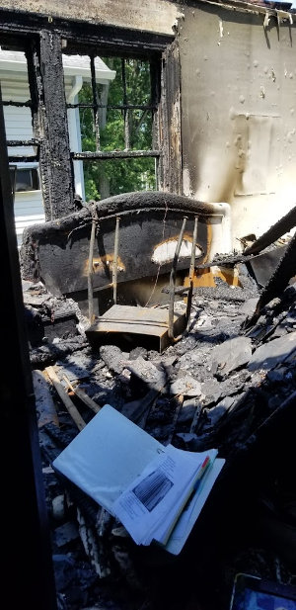

The lessons and values I had gained through my study of Torah prepared me to tackle many of these questions. That Rosh Hashanah I sat in synagogue and I contemplated the events of my life, I reflected on the events of the fire, and I praised G-d for sparing my life.
My time in Israel put me on course towards a more purposeful life. The fire taught me how to be a receiver, something that I was never comfortable with. I learned to appreciate the support from friends, family and the Jewish community on a much greater magnitude. I learned that physical possessions, although they do hold importance and sentiment, can never share the same value as states of being: connection, love, happiness, fulfillment, gratitude, purpose. And I learned to be incredibly thankful to G-d.

Overcome with Emotion and Gratitude
Rosh Hashanah is a time to crown G-d and recognize His Kingship. On Rosh Hashanah our fate for the year is written and later sealed. We read in the machzor that it will be determined who live and who will die – who by water and who by fire, who by sword and who by beast... As I read these words the magnitude struck me. I was overcome with emotion and gratitude realizing that last year it was determined that I would be in a fire and endure great suffering, but my life would be spared. It could have been determined differently for me.
Months passed after the fire and thank G-d I slowly rebuilt, with significant help from the Jewish community at large who graciously offered their homes, food, clothes, supplies, money, and continued support. I will always be indebted for these significant acts of kindness and hope to one day pay them forward. At the end of January, I returned to Israel on the Aish Destiny trip, a women’s retreat to reconnect, rejuvenate and revitalize. It did just that and more.

My Prayers were Finally Answered
While in Israel, I met my now husband. I had been searching and praying for many years to find my bashert (soulmate) and my prayers were finally answered. Could this have happened if I had not endured certain events and grown in specific ways earlier in the year?
Would I be at this same place I am now if I had not been guided on a specific path in life and through my various trials and tribulations? Were my prayers that Rosh Hashanah heard?
We don’t always understand why bad or difficult things happen. There is so much confusion, suffering, and uncertainty. But we are not in full control. There is a greater power, a Source, a Creator that has painted a picture for every one of us. We do not always see the picture clearly, but sometimes we do get a glimmer of light illuminating it for a split second. It is hard to understand when we are left in the dark.
But we should not lose sight of the fact that there is a plan and it is ultimately good, we just do not see the full tapestry yet.

The author at her wedding

This Rosh Hashanah take the time to reflect on your past, give thanks, pray for the upcoming year, and recognize the magnitude of the day and the power it can hold.
May we all have our prayers answered and revealed to us quickly.

Reprinted from the aish.com Rosh Hashanah website.

My 9/11 Rosh Hashanah
Blowing Shofar Amidst
the Smoke and Ashes
By Menachem Posner

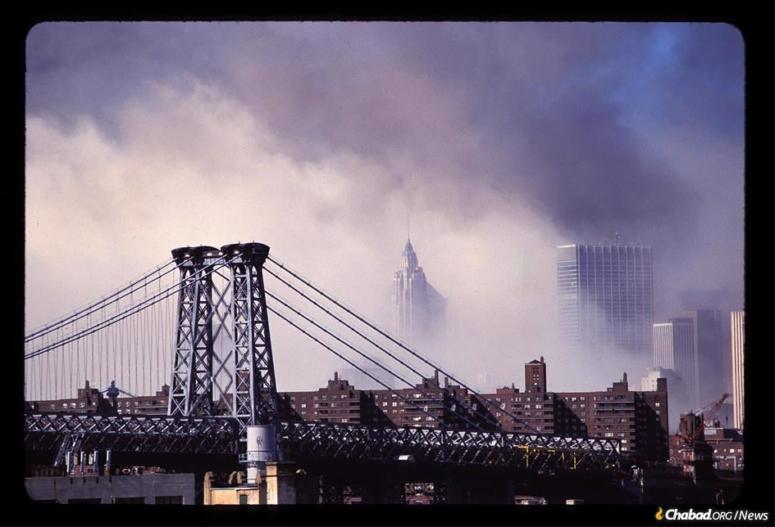
Lower Manhattan after the terrorist attacks of Sept. 11, 2001 (Photo: Barry Goldstein)
The image is seared into my mind. Walking over the Williamsburg Bridge from Brooklyn to Manhattan in the early morning, looking to the right, and seeing giant plumes of smoke rising from the spot where the Twin Towers had stood just days before.
New Yorkers don’t generally talk to strangers. But everything was different in those days after 9/11. We were one city, one people. The fear had touched us all in a place that was deeper than race, socioeconomic status or culture. We were all humans in need of comfort.
My friend Dani and I crossed the bridge together with a cyclist. He told us that he was going away. He did not know where, and he didn’t care. He just needed to get out of New York to escape the terrible destruction that had happened there.

On My Way to Blow Shofar for
Elderly Retirees in Gramercy Park
But we weren’t going far. It was the first day of Rosh Hashanah, and I was on my way to blow shofar for a small congregation of elderly retirees in Gramercy Park.
In my hand, I had a leather bag with a shofar inside of it. Since I did not yet own a shofar of my own (I was 18 at the time), I had borrowed one from my aunt and uncle. Its mouthpiece was riddled with tooth marks made by my overenthusiastic cousins, but it made a fine sound. I had spent a few hours in my dorm room practicing the day before, and I was sure that I would be able to blow it just fine.
I was accompanied by Dani, whom I had met in Russia the summer before, when we were co-counselors at the Chabad summer camp outside of Moscow. His parents were longtime refuseniks, and he knew Russian even though he had grown up in Israel. I, on the other hand, had learned a handful of words from my campers. Our common language was Hebrew, and we struck up a friendship (today, he is a Chabad emissary in S. Petersburg, and we still keep in touch).

We Felt Like We Were
Sucked into a Different Era
And there we walked in the early dawn light, smelling the smoke of destruction and wondering how exactly the world would survive the new year, 5762.
When we arrived at the synagogue—a narrow affair sandwiched between walk-up apartments, Chinese laundries and convenience stores—we felt like we were sucked into a different era.
The once-grand but never large lobby bore fading photos of the congregation’s Hebrew school, none more recent than the 1970s, and the smell of musty carpets and aged books pervaded the building.
As we entered the sanctuary (according to a plaque on the wall it had been paneled in the 1950s), we saw perhaps a half-dozen men scattered throughout the room. Some pews were so covered with old books and pamphlets, there was no room to sit. Near the front sat the rabbi.
Wrapped in his tallit, the rabbi turned to greet us. He wore a white kittel with silver braid, the likes of which I had never seen before, which seemed to be nearly as old as he was. He wore his beard in a neatly kept goatee. Known in Yiddish as a komatz berdel, the style had been popular among rabbis decades before I was born.
“We don’t hurry on Rosh Hashanah,” he said in Yiddish, apparently apologizing for the weak showing. “By the time we are ready to start, we will have several dozen people here.”
He spoke with a grand confidence that meshed well with his strong Hungarian-Jewish accent. We soon learned that he had once been a well-known Yiddish radio personality and political activist who was famed for his oratory skills.
The rabbi began the service by belting out “Adon Olam” in a tune I had never heard before but which has stuck with me until this day. One by one, worshippers trickled in. I do not know if the rabbi’s “several dozen” ever materialized, but there was a motley crew of Jews—the men downstairs and the women above—mostly in their 70s and 80s.

G-d Would Surely Bring Those Evil Men to Justice
After Torah reading, it was time for the rabbi’s sermon. He spoke powerfully about “the evil men who knocked down those towers,” assuring his congregation (and perhaps himself) that G-d would surely bring them to justice.
It would be the rabbi’s first year not blowing the shofar himself, and he was not quite ready to give up his sacred duty. He stood with me at the bimah in the center of the sanctuary and read along with me the mystical prayers said by the shofar-blower.
After reciting the blessings, I closed my eyes and blew with all my might. I blew for the souls that had been cruelly snuffed out on 9/11. I blew for the congregation, wishing them another year of life and health. I blew for my generation, realizing that we were entering into an era when security was not something that we could ever take for granted.

A Reason for G-d’s Hammer-Blow that Rammed into Our World
And I blew for G-d, who saw mysterious beauty in the destruction and had a reason for the hammer-blow that had rammed into our world.
As we chatted with the congregants after services, it became clear that they were agitated and not very clear about what was happening just a few blocks away. “It’s that zero-ground thing,” offered one woman, referring to the site of the attacks, which had been dubbed ground zero. “That’s why there are so few people in shul; they were scared away by that zero ground.”
There was a man in the synagogue from Brooklyn who was spending the holiday with his elderly mother in a nearby Beth Israel Hospital. He asked us to accompany him there to blow shofar for her and for another man who was in the hospital.
As we approached the hospital, we were greeted by walls covered with photocopied pages, each one with a photo, name, and brief description of an individual—a stark reminder of the terrible trauma that Manhattan was living through. People were still missing under the rubble, and family members were desperate for news.
We blew shofar for the two elderly people and shared a meal with their children. Homemade gefilte fish, sweetmeats and compote were a much-welcomed repast at that time of the afternoon.
Dani and I then spent the rest of the afternoon walking through the halls of the hospital, offering to blow shofar for any Jews who had not heard it. Along the way we met the Jewish chaplain, and he was happy to assign us certain floors, thus easing his burden.
We returned the following day for a repeat performance, and then remained in Manhattan until nightfall when we took a car service back home.

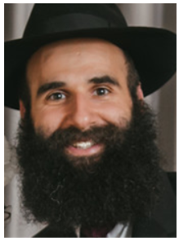
Rabbi Menachem Posner

As we rode back to Brooklyn, the driver played the radio. For the first time since the attacks, there was more than just news updates. Ads, talk shows, the regular programming was coming back on air. It felt good to hear the usual irreverence of New York AM radio. It meant that we were still alive, still ourselves.
And with that, we were ready for the Jewish year of 5762.
Reprinted from the Rosh Hashanah website of Chabad.Org Magazine.

